
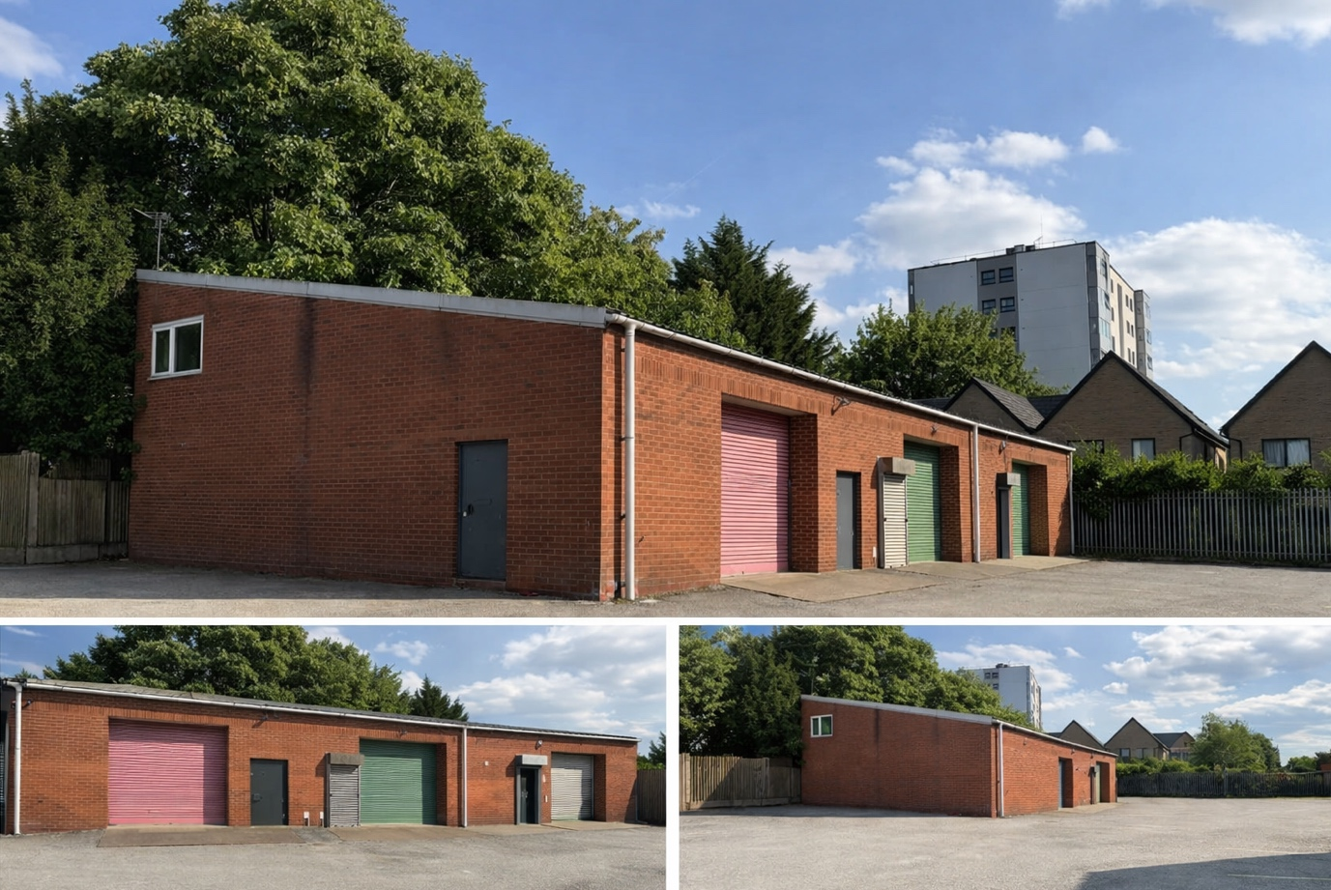
PRIME COMMERCIAL UNITS TO LET COMING SOON
UNITS 1, 2 & 3 660 CHESTER ROAD, ERDINGTON, BIRMINGHAM, B23 5TE
A DETACHED BLOCK OF 3 PURPOSE BUILT COMMERICAL UNITS, TO LET INDIVIDUALLY OR TOGETHER LOCATED ON MAIN ARTERIAL ROUTE A452.

Summary

• Three industrial/warehouse units in detached block.
• Approx 1200 SQ F Gross Internal Area PER UNIT
• Approx 800 SQ F Ground Floor Area per unit
• Ideal for a range of businesses, including trade counters.
• Ample car parking and loading areas on site
• Popular mixed-use business park

Units 1, 2 & 3 are situated on the popular Chester Road Station Industrial Park, located in the Erdington / Wylde Green area of Birmingham. Prominently position on the main Chester Road, a major thoroughfare in the West Midlands A452/A15127. Exceptional average of over 70,000 passing vehicles per day.

Description
Detached industrial premises with tall roller shutter door to each unit, personnel doors, W/C, mezzanine floors in units 1 & 2.
Ideally suited for a range of commercial businesses.
Ample car parking and loading areas on site.

Measurements
UNIT 1 – 800 SQ F GROUND FLOOR + 320 SQ F MEZZANINE
UNIT 2 – 800 SQ F GROUND FLOOR, 420 SQ F MEZZANINE
UNIT 3 – 800 SQ F GROUND FLOOR

Business Rates
Unit 1 - £8,700 qualifies for small business rates relief
Unit 2 - £9,700 qualifies for small business rates relief
Unit 3 - £6,900 qualifies for small business rates relief

Please make you own enquires with the relevant local authority
https://www.gov.uk/find-business-rates

Tenure
The units are available by way of a new full repairing and insuring lease.
The buildings insurance is paid by the Landlord and recharged to the tenant on a SQ F proportion basis.

Services
The property has a mains 3-phase electrical supply.
Each unit has its only – electrical supply, water supply, gas supply.

Service Charge
A service charge on this property for the maintenance of the Business Park common areas.

VAT
The rent on this property is not subject to VAT.

Legal Costs
Each party will be responsible for their own legal costs incurred in setting up the lease.

Viewing
By prior arrangement with PDN ESTATE MANAGEMENT.

Energy Performance Certificate
The property has an Energy Performance asset rating of Band B.

Location
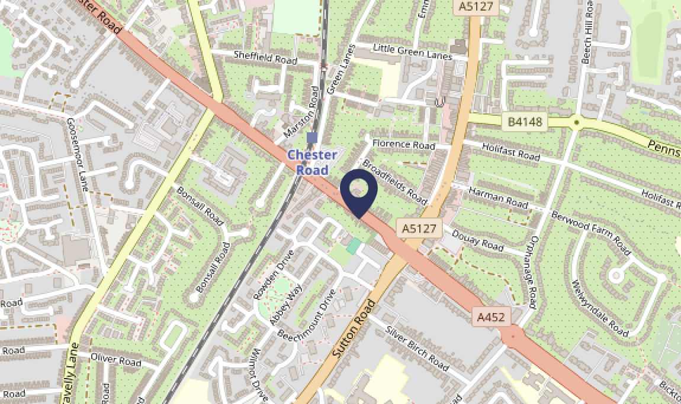

CONTACT
STUART NEEDLE @ PDN ESTATE MANAGEMENT
stuart@pdnem.co.uk
07583512449

